2021 WATER QUALITY REPORT FOR
RUTHVEN WATER SUPPLY
This report contains important information regarding the water quality in our water system. The source of our water is groundwater. Our water quality testing shows the following results:

CONTAMINANT | MCL-(MCLG) | Compliance |  | Date | Violation | Source
 |  | Type | Value & (Range) |  | Yes/No
Copper (ppm) | AL=l.3 (1.3) | 90th | 0.27 (ND - 0.38) | 2021 | No | Corrosion of household plumbing systems; Erosion of natural deposits; Leaching from wood  preservatives
Lead (ppb) | AL=15 (0) | 90th | 1.00 (ND -2) | 2021 | No | Corrosion of household plumbing  systems; erosion of natural deposits
950 - DISTRIBUTION SYSTEM
Chlorine (ppm) | MRDL=4.0 (MRDLG=4.0) | RAA | 2.0 (1.51 - 3.04) | 06/13/2021 | No | Water additive used to control microbes
01 - WELL 1 OR 3 @ TREATMENT PLANT TAP
Combined Radium (pCi/L) | 5 (0) | SGL | 1.4 | 05/25/2021 | No | Erosion of natural deposits
Sodium (ppm) | NIA (NIA) | SGL | 120 | 04/08/2019 | No | Erosion of natural deposits; Added to water during treatment process

Note: Contaminants with dates indicate results from the most recent testing done in accordance with regulations.

DEFINITIONS

- Maximum Contaminant Level (MCL)-The highest level of a contaminant that is allowed in drinking water. MCLs are set as close to the MCLGs as feasible using the best available treatment technology.
- Maximum Contaminant Level Goal (MCLG) -- The level of a contaminant in drinking water below which there is no known or
. expected risk to health. MCLGs allow for a margin of safety.
- ppb -- parts per billion.
- ppm -- parts per million.
- pCi/L - picocuries per liter
- NIA-Not applicable
- ND -- Not detected
- RAA - Running Annual Average
- Treatment Technique (TT) -A required process intended to reduce the level of a contaminant in drinking water.
- Action Level (AL) - The concentration of a contaminant which, if exceeded, triggers treatment or other requirements which a water system must follow.
- Maximum Residual Disinfectant Level Goal (MRDLG) - The level of a drinking water disinfectant below which there is no known or expected risk to health. MRDLGs do not reflect the benefits of the use of disinfectants to control microbial contaminants.
- Maximum Residual Disinfectant Level (MRDL) - The highest level of a disinfectant allowed in drinking water. There is convincing evidence that addition of a disinfectant is necessary for control of microbial contaminants.
- SGL - Single Sample Result
- RTCR- Revised Total Coliform Rule
- NTU - Nephelometric Turbidity Units

GENERAL INFORMATION

Drinking water, including bottled water, may reasonably be expected to contain at least small amounts of some contaminants. The presence of contaminants does not necessarily indicate that water posed a health risk. More information about contaminants or

March 02, 2022, CCR2021 RUTHVEN WATER SUPPLY PWSID: 7465010 Page 1

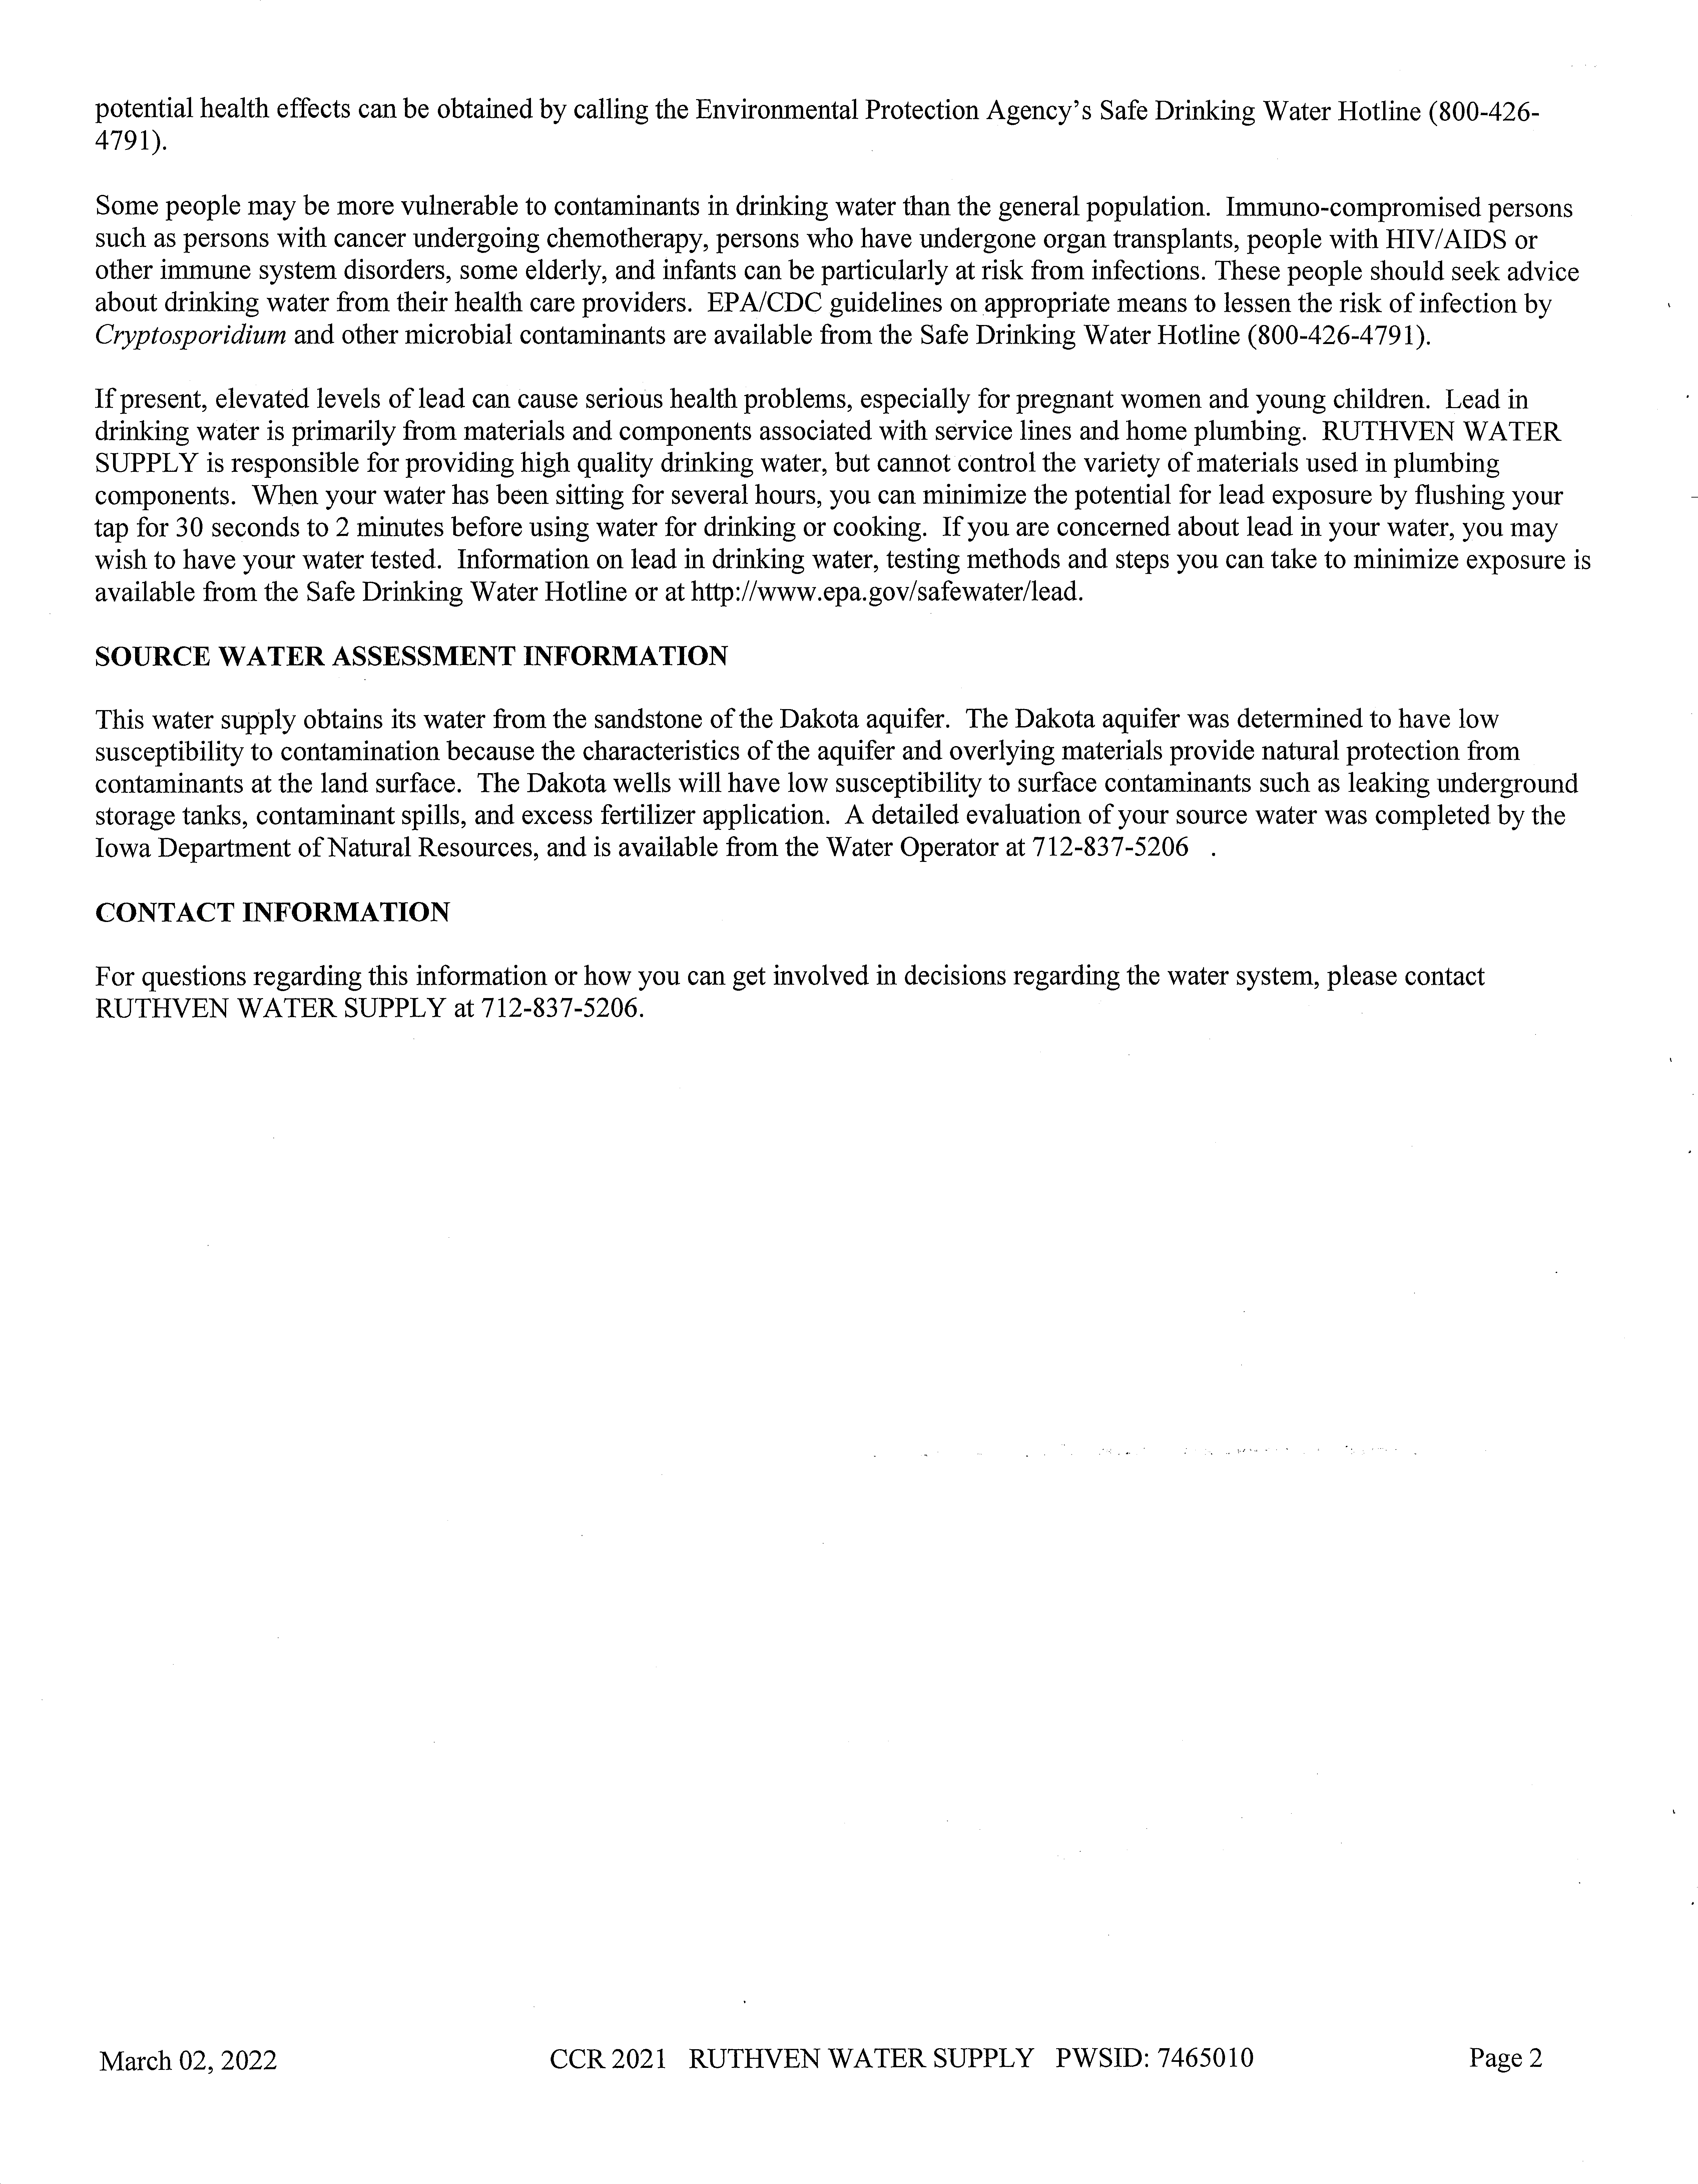

The 2021 Ruthven Water Supply Consumer Confidence Report (CCR) will not be directly distributed to customers. Copies of the CCR are available upon request at Ruthven City Hall, 1305 Gowrie Street or by calling 712-837-5355 to request a copy be mailed to you. They are also posted at City Hall, Ruthven Post Office and Iowa State Bank, Ruthven Branch for your review.

